JPO 152 Assignment 6
Rotation
Due date: 20th May 2013
Surname:
Student No:
Field Of Study:
Group:
Total | /20

I am aware of the University of Pretoria’s plagiarism clause and steps that may be taken against me, should I be found guilty. This work is my original effort.

Signature: __________________
Question 1 [4]
A gear system relies of two object rotating about different axes. In the gear system below, the radius of the first gear is half that of the second gear.
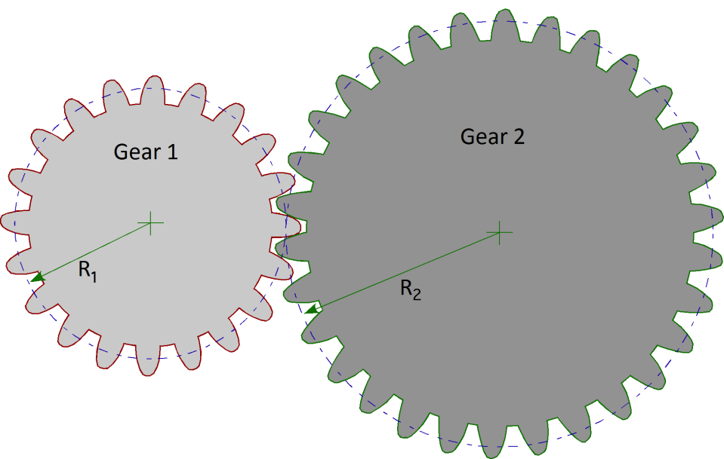
If gear 1 is rotated at an angular velocity of $ω$ by an outsider, then what is the angular velocity of gear 2 in terms of $ω$? Show all your working
The linear speeds of two point where the gears touch must be equal in magnitude but opposite in direction in order for the gear system to function, i.e.$v_{1}=v_{2}$ at point of contact. Since $v=ωr$ for any point on a rotating object then for the point of contact
$$ωR_{1}=ω_{2}R_{2}$$
$$ω_{2}=ω\frac{R_{1}}{R_{2}}=ω\frac{R_{1}}{2R_{1}}=\frac{ω}{2}$$
Question 2 [6]
- If the net torque on a system is zero, is the net force on the system always zero? Explain or draw a suitable example to justify your answer. (3)
The net force does not have to be zero. Two marks for a suitable example such as:
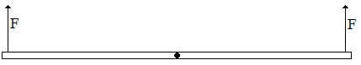

- If the net force on a system is zero, is the net torque on the system always zero? Explain or draw a suitable example to justify your answer. (3)
The net torque does not have to be zero. Two marks for a suitable example such as:
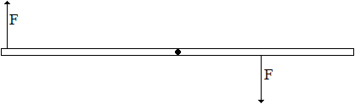

Question 3 [9]
- Is it possible for an object to have the same moment of inertia for all axes of rotation? If yes give an example of such an object, if no then explain (3)
No. The parallel axis theorem states that if any object is rotating about an axis not on its centre of mass then its rotational inertia is
$$I=I_{com}+mh^{2}$$
Where h is the distance from the axis of rotation to the centre of mass and $I_{com}$ is the rotational inertia for the object if it were rotating about its centre of mass. Since $I_{com}$ is a constant value for any given object and h will change for any two axes not the same distance from the centre of mass and does not rely on the shape of the object, then no object will have the same I for all axes
- The diagram below shows three flat disks (of the same radius) that can rotate about their centres like merry-go-rounds. Each disk consists of the same two materials, one denser than the other (density is mass per unit volume). In disks 1 and 3, the denser material forms the outer half of the disk area. In disk 2, it forms the inner half of the disk area. Forces with identical magnitudes are applied tangentially to the disk, either at the outer edge or at the interface of the two materials, as shown.
$$\vec{F}$$
$$\vec{F}$$
$$\vec{F}$$
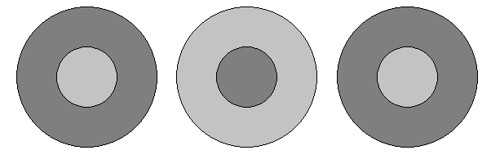
Disk 3
Disk 2
Disk 1

Rank the disks according to
  - the torque about the disk centre. Explain (3)
1=2, 3. $τ=\vec{r}×\vec{F}=rF\sin{θ}$thus since F is the same in each case and $θ=90°$ in each case then the greater the value for r the greater the torque acting on the object (where r is distance from axis of rotation to place where force is applied)
  - the rotational inertia about the disk centre. Explain (4)
2, 1=3
$$I=I_{disk}+I_{ring}=\frac{1}{2}M_{disk}{R_{disk}}^{2}+\frac{1}{2}M_{ring}\left({R_{disk}}^{2}+{R_{max}}^{2}\right)=\frac{1}{2}ρ_{disk}A_{disk}{R_{disk}}^{2}+\frac{1}{2}ρ_{ring}A_{ring}\left({R_{disk}}^{2}+{R_{max}}^{2}\right)$$
$$=πρ_{disk}{R_{disk}}^{4}+πρ_{ring}\left({R_{max}}^{2}-{R_{disk}}^{2}\right)\left({R_{disk}}^{2}+{R_{max}}^{2}\right)$$
$$=πρ_{disk}{R_{disk}}^{4}+πρ_{ring}\left({R_{max}}^{4}-{R_{disk}}^{4}\right)=π{R_{disk}}^{4}(ρ_{disk}-ρ_{ring})+πρ_{ring}{R_{max}}^{4}$$
Hence if $ρ_{disk}>ρ_{ring}$ then first term is positive and I is big, but if $ρ_{disk}<ρ_{ring}$ then first term is negative and I is small

